Face polygon, Inc.

Software Design Document
Face Polygon

Attili Uday Bandi Dinesh Kumar
Ambati Sai Sudheer Reddy Dandu Geet Kamal Tej
Kandula Mohan Sai

Version 1.0
October 23, 2016

Table of Contents
1.1 Purpose of this document 3
1.2 Scope of the development project 3
1.3 Definitions, acronyms, and abbreviations 3
1.4 References 3
1.5 Overview of document 3
2.1 Overview of modules / components 4
2.2 Structure and relationships 4
2.3 User interface issues 5
3.1 Component template description 5
3.2 X Component (Class) 5
3.3 Y Component (Class) 5
3.4 Z Component (Class) 6

1. Introduction

1.1 Purpose of this document
The purpose of this software design document is to provide description of the Face Polygon system and also to provide insight into the structure and design of its components. In short, this document is meant to equip the reader with a solid understanding of the inner workings of the Face Polygon system.

1.2 Scope of the development project
Polygon app can be used to know about the people around you with just one click, you just need a photo of the person and you will get the he provided. Our goal is to let students of same interests in a college to know each other and make them work together. The people working together can be more productive and also they will learn working in team. Our app also has scope of being used as an automatic student attendance system, college has to provide students with the app and one student can join other, our corporate goal is to reach to all the colleges across the country and to be in the hands of every student.

1.3 Definitions, acronyms, and abbreviations
Firebase Auth is a service that can authenticate users using only client-side code. It supports social login using Facebook, GitHub, Twitter and Google. Additionally, it includes a user management system whereby developers can enable user authentication with email and password login stored with Firebase

1.4 References
https://en.wikipedia.org/wiki/Firebase

1.5 Overview of document
The document gives a brief overview of how the backend design is made and the connectivity among each component is also very well defined. The document covers up the class diagram and the state diagram of the application.

2. System architecture description

2.1 Overview of modules / components
Face Polygon has mainly three components, the Database, the application and the server. The app communicates with the database and server and there is also communication of the database and server through the application.

2.2 Structure and relationships
Make clear the interrelationships and dependencies among the various components. Structure charts can be useful here. A simple finite state machine can be useful in demonstrating the operation of the product. Include explanatory text to help the reader understand any charts.
- USER REGISTRATION & WELCOME
- Only appears once (the first time the application is run)
- Allows the user to register with the Face polygon server
- Enables the user to customize his/her account settings and preferences
- UPLOADING A FRIEND’S PHOTO
- Once user logs in he can upload a friends photo to server
- REQUEST FOR DETAILS
- User should send a request for details after uploading a photo
- This option is available only after uploading the photo
- RECEIVE NOTIFICATIONS
- User receives a request if someone request him for details
- Can approve or reject request

2.3 User interface issues
User interface problem arises when different customers uses different android OS. We are using app combat version layout which suits our app but may not work in some versions. Students our target customers can easily understand our app interface as it was very clear and simply designed.

3. Detailed description of components

3.1 Component template description
This section is not part of your design. It is the pattern you will use to describe the components given in subsections 3.2 - 3.n. Each part of the template will be identified by a label. Here in 3.1, you must briefly explain the purpose of each point. To make the presentation clear, use a table or bullet list. You may adapt the template suggested below to your particular needs (although deviations from the suggested template should be minimal and well motivated).

3.2 X Component (Class)
Register user class has no attributes he/she has to be a member in order to perform any action.
User class has first name, last name, username and password. It can perform Register and Login action along with updating and logging out of account.
Admin can delete account and also can view profiles of the users. He can also edit the database by changing the requirement and updating the software.

3.3 Y Component (Class)
Register class is called from the user class when he/she performs an operation of registration. It takes in the details of the user and set those values into the database. There is simple connection between the class user and register class.
Login class takes in username and password from existing users and makes them access the database. They can update their details in database and can also upload photo of someone else and request for details.
Activity class, photo uploaded will be sent to face-plus-plus and the values thus received are compared with the values in the database and if any match found the user details are displayed if its public or a request will be sent to the photographed person.

3.4 Z Component (Class)
Database and server are treated as a second system in the class diagram. Database takes in every input from the user and stores it. Every data and every photo request is stored till it was sent to the photographed person to let them see how they were photographed and after that no information will be stored. Database requires username and password to authenticate. It returns all the data received from the server.
Server just takes the photo from the user and returns the value to the database.
4. Reuse and relationships to other products
We are using everything from scratch beginning from our firebase database to face plus plus server. The app doesn’t reuse but it has relationship with other products. It uses the face recognition algorithm written by face-plus-plus which is reusable for non-commercial purposes. The face recognition plays key role in our software so reuse is very important.

5. Design decisions and tradeoffs
We actually opted to use 000webhost.com and use PHP for creating the database to store user login and registration details. Instead, we are using Google Firebase UI in our app which is very light and very productive. Firebase really helps in creating an easy registration and login using just 4 lines of code. This is the main reason behind leaving the 000webhost.com‘s hosting services. Firebase uses JSON, the firebase server and Android client will exchange data using the JSON format. JSON is being used due to its versatility and because of the fact that an implementation is available for both PHP and JAVA. Local Android client of Face Polygon will never access this database directly; it will instead issue requests to the server.
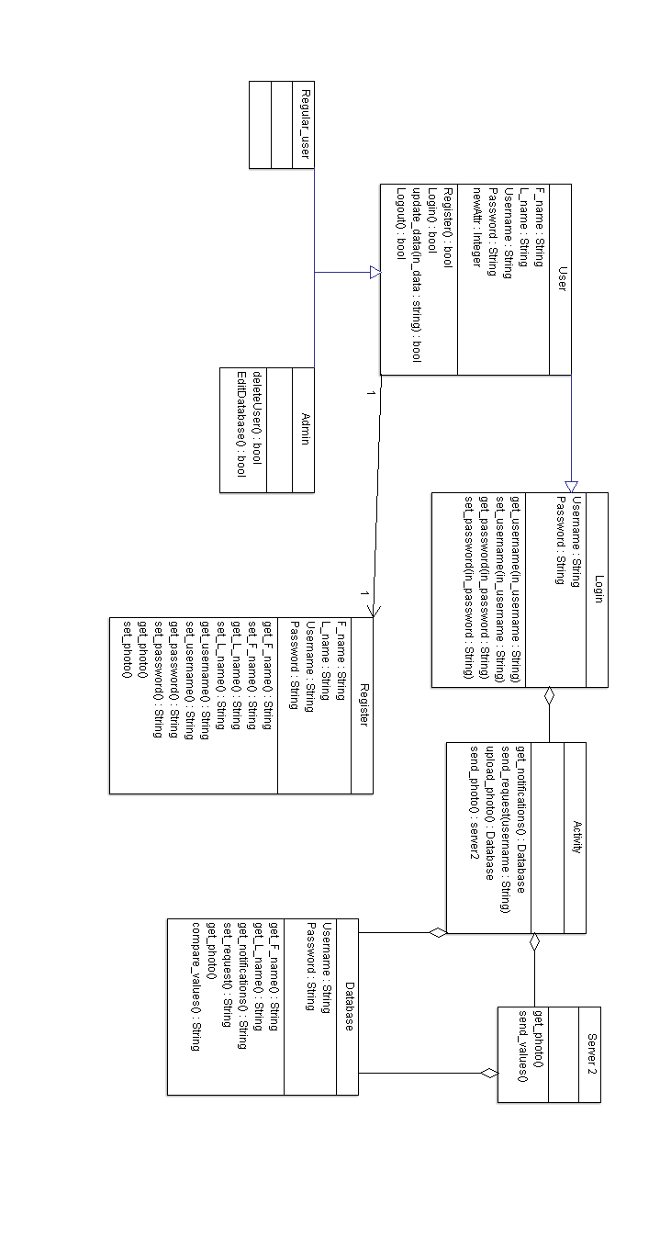
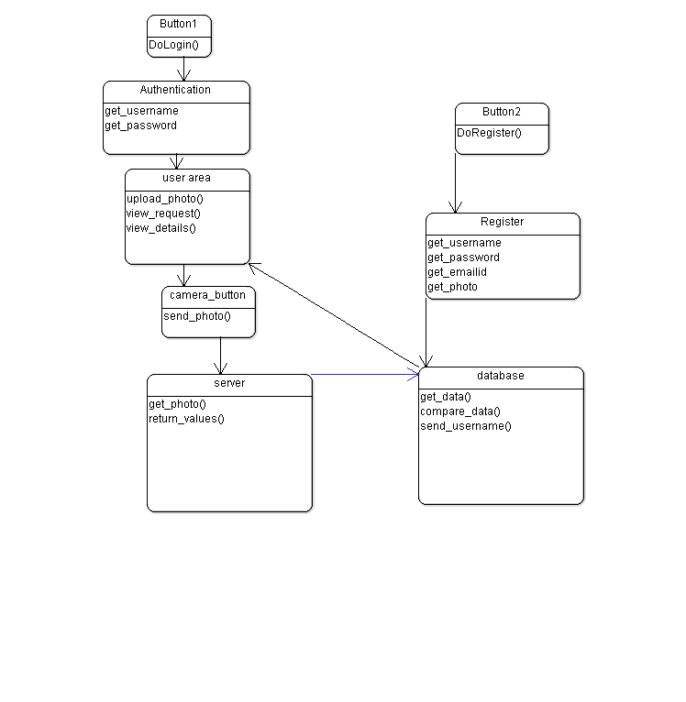
6. Pseudocode for components

Java code for login activity which allows the user to login through Facebook, Gmail or Email.
import android.content.Intent;
import android.os.AsyncTask;
import android.support.annotation.NonNull;
import android.support.v7.app.AppCompatActivity;
import android.os.Bundle;
import android.support.v7.widget.ListViewCompat;
import android.support.v7.widget.RecyclerView;
import android.util.Log;
import android.view.KeyEvent;
import android.view.View;
import android.view.inputmethod.EditorInfo;
import android.widget.ArrayAdapter;
import android.widget.Button;
import android.widget.EditText;
import android.widget.ListView;
import android.widget.TextView;
import com.firebase.ui.auth.AuthUI;
import com.firebase.client.Firebase;
import com.google.firebase.auth.FirebaseAuth;
import com.google.android.gms.tasks.OnCompleteListener;
import com.google.android.gms.tasks.Task;
import android.speech.tts.TextToSpeech;
import android.speech.tts.TextToSpeech.OnInitListener;
import com.memetix.mst.language.Language;
import com.memetix.mst.translate.Translate;
import java.util.ArrayList;
import java.util.Arrays;
import java.util.Locale;
import java.util.Random;
public class MainActivity extends AppCompatActivity implements View.OnClickListener {
private static final int RC_SIGN_IN = 0;
private static final String FIREBASE_URL = "https://fir-basic-35208.firebaseio.com/";
private Firebase firebaseRef;
private FirebaseAuth auth;
private static Button btn;
@Override
protected void onCreate(Bundle savedInstanceState) {
super.onCreate(savedInstanceState);
setContentView(R.layout.activity_main);
Firebase.setAndroidContext(this);
firebaseRef = new Firebase(FIREBASE_URL);
findViewById(R.id.sendButton).setOnClickListener(new View.OnClickListener() {
@Override
public void onClick(View v) {
String newItem = messageText.getText().toString();
arrayList.add(newItem);
adapter.notifyDataSetChanged();
sendMessage();
}
});
auth = FirebaseAuth.getInstance();
if (auth.getCurrentUser() != null) {
Log.d("AUTH", auth.getCurrentUser().getEmail());
} else {
startActivityForResult(AuthUI.getInstance()
.createSignInIntentBuilder()
.setProviders(
AuthUI.FACEBOOK_PROVIDER,
AuthUI.EMAIL_PROVIDER,
AuthUI.GOOGLE_PROVIDER)
.build(), RC_SIGN_IN);
}
findViewById(R.id.log_out_button).setOnClickListener(this);
}
public void sendMessage() {
EditText textInput = (EditText) findViewById(R.id.messageText);
String message = textInput.getText().toString();
if (!message.equals("")) {
Random rand = new Random();
String author = "TestUser" + rand.nextInt(1000);
ChatMessage cMessage = new ChatMessage(author, message);
firebaseRef.push().setValue(cMessage);
textInput.setText("");
}
}
@Override
protected void onActivityResult(int requestCode, int resultCode, Intent data) {
super.onActivityResult(requestCode, resultCode, data);
if (requestCode == RC_SIGN_IN) {
if (resultCode == RESULT_OK) {
Log.d("AUTH", auth.getCurrentUser().getEmail());
} else {
Log.d("AUTH", "Not authenticated");
}
}
}
@Override
public void onClick(View view) {
if (view.getId() == R.id.log_out_button) {
AuthUI.getInstance().signOut(this).addOnCompleteListener(new OnCompleteListener<Void>() {
@Override
public void onComplete(@NonNull Task<Void> task) {
Log.d("Auth", "Logged out");
finish();
}
});
}
}
}

Complete code of the login and registration which takes the username password and photo from the user and creates an account and stores the data in the database.

After the user gets logged in he/she will be able to access the Main activity area. The Main activity contains the camera option and also a navigation drawer which contains the notifications display and logout option.

